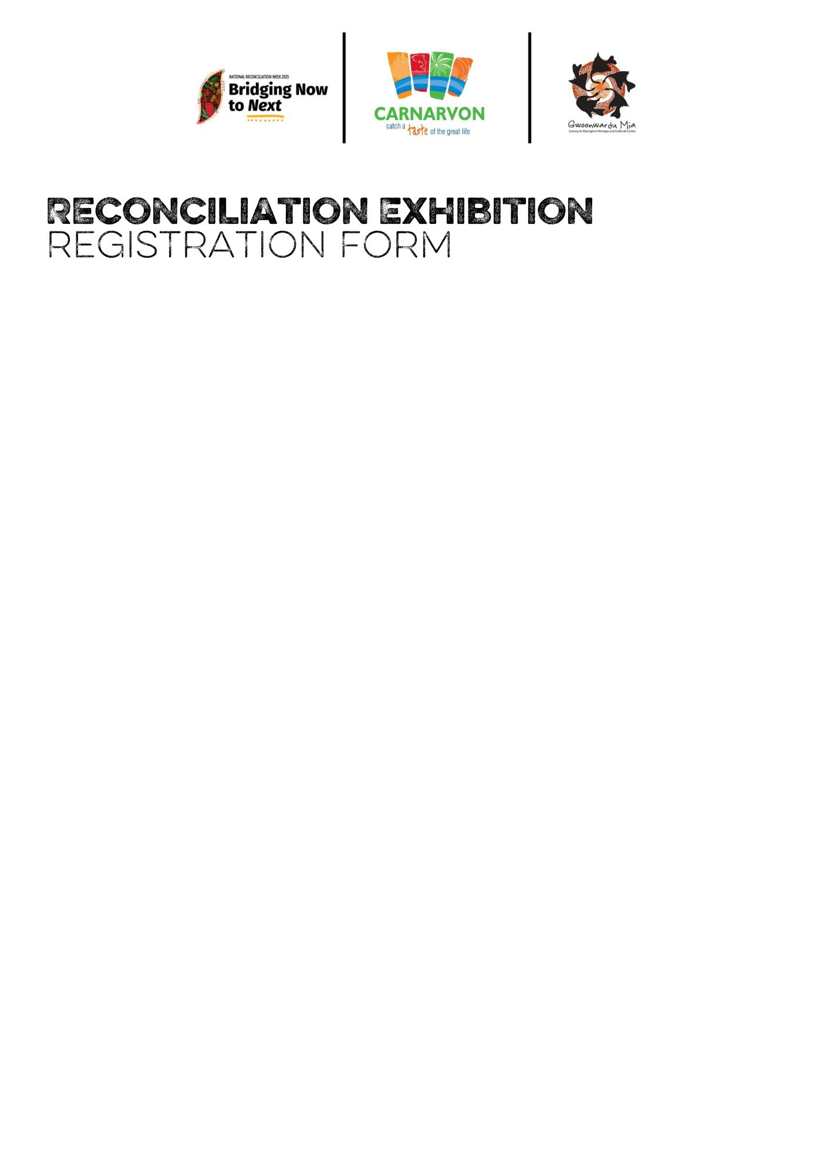

Complete the form with your artwork details and contact information for exhibition preparation and support. By submitting, you agree to the exhibition's terms and conditions.

Please register **before 30 April 2025** by submitting this form at the Library and Art Gallery, The Community Art Hub, or Gwoonwardu Mia

Alternatively, register online here: <https://forms.office.com/r/iv5D9RGN9y>

1. Artist full name

-----------------------------------------------------------------------------------------------------

1. Email address

-----------------------------------------------------------------------------------------------------

1. Contact number

-----------------------------------------------------------------------------------------------------

1. Title of artwork

-----------------------------------------------------------------------------------------------------

1. Story behind artwork

-----------------------------------------------------------------------------------------------------

-----------------------------------------------------------------------------------------------------

-----------------------------------------------------------------------------------------------------

-----------------------------------------------------------------------------------------------------

-----------------------------------------------------------------------------------------------------

-----------------------------------------------------------------------------------------------------

1. Date artwork created

-----------------------------------------------------------------------------------------------------

1. Size

-----------------------------------------------------------------------------------------------------

1. Medium

-----------------------------------------------------------------------------------------------------

1. Artwork price

-----------------------------------------------------------------------------------------------------

1. Do you have an ABN, if so please provide

-----------------------------------------------------------------------------------------------------

1. Is the artwork ready to hang?

----------------------------------------------------------------------------------------------------

1. Do you need assistance with making your artwork ‘ready to hang’

-----------------------------------------------------------------------------------------------------

1. Consider my artwork for the Shire of Carnarvon Innovate RAP 2025-2027

*(This opportunity is only for First Nations artists, please tick to confirm)*