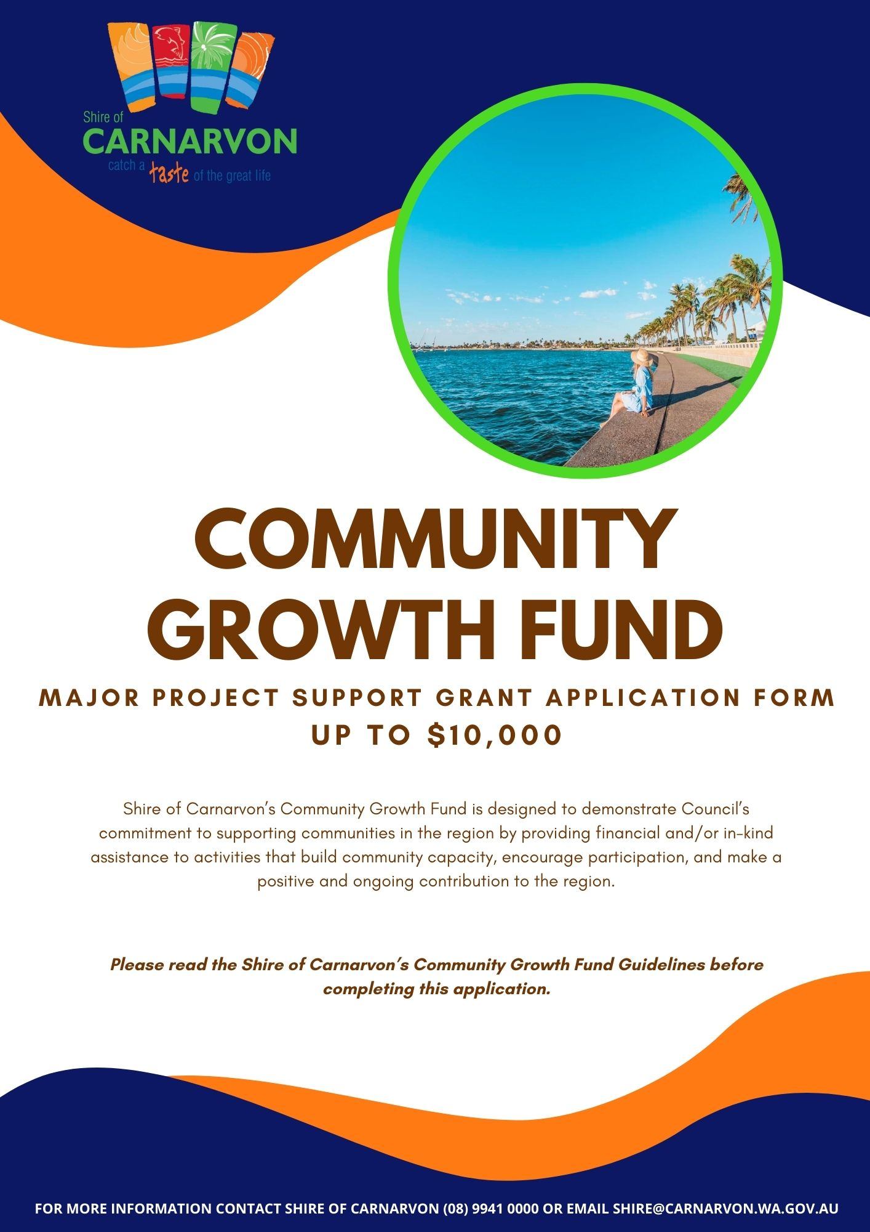

DETAILS OF YOUR ORGANISATION

Organisation Name
Street Address
Postal Address
Contact Number
Email Address

CONTACT PERSON

Full Name
Position
Contact Number
Email Address

TYPE OF ORGANISATION

Select your organisation type:
☐ Not-for-profit Organisation
☐ Incorporated Organisation

Does your Organisation have an Australian Business Number (ABN)?
☐ Yes ☐ No

Is your Organisation registered for GST?
☐ Yes ☐ No

Does your Organisation have Public Liability Insurance?
☐ Yes ☐ No ☐ N/A
Insurance Amount: $

GRANT HISTORY

Has the Organisation previously received a Community Growth Fund Grant with the Shire of Carnarvon?
☐ Yes ☐ No

If yes, please provide details below and has this grant been acquitted?

Project Name | Amount | Year Funded

GRANT DETAILS

What category does your application fit within:
☐ Operational (e.g. are you requesting financial assistance for a rates notice)
☐ Event (e.g. is your application for an event/activity)
☐ Project (e.g. is your application for a development project/infrastructure etc.)
☐ In-Kind (e.g. hire/usage of Shire facilities or assets)

Funding amount requested (ex. GST) If your organisation is registered for GST, you will be paid GST on top of the below requested amount.
$

Have you spoken with the Community Development Officer in relation to this application?
☐ Yes ☐ No

How will the Shire of Carnarvon be recognised for its support?
☐ Council banners ☐ Logo on the website
☐ MC announcements ☐ Radio/ Television
☐ Keynote speeches ☐ Logo on advertising materials
☐ Social media ☐ Other (please specify) ______________________________

PROJECT DETAILS

Project Name
Project State Date |  |  | Project End Date
Is your event, project, or activity a one-off or recurrent? |  |  | ☐ One-off ☐ Recurrent

Detailed project description (200 words or less):

Select the demographics this project will target:
☐ Men ☐ Women
☐ Family ☐ Tourists
☐ Children aged 0-11 yrs ☐ Young people aged 12-25 yrs
☐ Aboriginal or Torres Strait Islander peoples
☐ People with disability/ special need
☐ Other (please specify) ________________________________________________________

Number of participants/ attendees expected (if applicable):

Is the event, project, or activity free?
☐ Yes ☐ No
If yes, please provide information and include estimated income in your budget.

Describe in 200 words or less how the project provides a direct or indirect benefit, including social and economic, for the community. These should be measurable and achievable.

In 200 words or less, what is the main reason you are applying for this funding and how does it meet a need in the community?

Will this project go ahead without Council’s funding?
☐ Yes ☐ No

Choose 1 (one) or more Strategic Community Plan objectives or strategies that your application aligns with, provide a detailed explanation of how it aligns with this objective or strategy.
☐ Our equitable community is actively involved in and is responsible for developing innovative, local solutions that transcend our region for a safe and unified 6701.
☐ Our economy fosters investment and productivity in industries befitting Carnarvon’s physical and natural environment and that grows our horizons.
☐ Our sustainable livelihoods create a community that can flourish into the future.
☐ Our holistic health care facilities provide services from the womb to the grave.
☐ Our educational opportunities from early childhood to adulthood are tailored and relevant to the individual.
☐ Our infrastructure, housing and amenities are high quality and accessible.
☐ Our community acknowledges our history and celebrates our diverse cultures.
☐ Our community is engaged, inclusive and supportive.

DETAILED BUDGET – INCOME AND EXPENSES

- Round all amounts to whole dollars.
- Demonstrate in your budget where your organisation is contributing a financial cost to the project.
- Council reserves the right to request further information on budget items.
*Example of the budget table below, please attach yours with the application.
Expenses | Cost | SoC Grant
Total Expenses | $ | $
Income (includes in-kind contributions)
Total Income | $ | $

Demonstrate other financial and/or in-kind contributions/partnerships that will assist in the delivery of this program/project or activity.

Funding Source | Amount

APPLICATION CHECKLIST

Please ensure all documents requested are attached to the application. Any application that is incomplete and does not have relevant documents attached will not be considered.

☐ Recent financial statement attached.
☐ Support letter attached.
☐ All questions have been answered.
☐ Project budget provided.
☐ Copy of public liability insurance provided.
☐ Appropriate person/s have signed.

Certification by the organisation:

I, the undersigned, certify that:

- I have read and will abide by the Shire of Carnarvon Community Growth Fund Guidelines.
- I am authorized to make this application on behalf of the organization.
- The information contained in this application is, to the best of your knowledge, true and accurate.
- The information you provide in your grant application will be used by the Shire to process and assess your application. The Shire may contact other funding agencies to verify funding requested from other agencies in support of your project.
- The information may be used by the Shire for the promotion of the Community Growth Fund or the promotion of funding outcomes for projects in Carnarvon.
- Willing to take part in the Shire’s communications and marketing material as requested by Shire staff.
Full Name
Position at Organisation
Signature
Date

