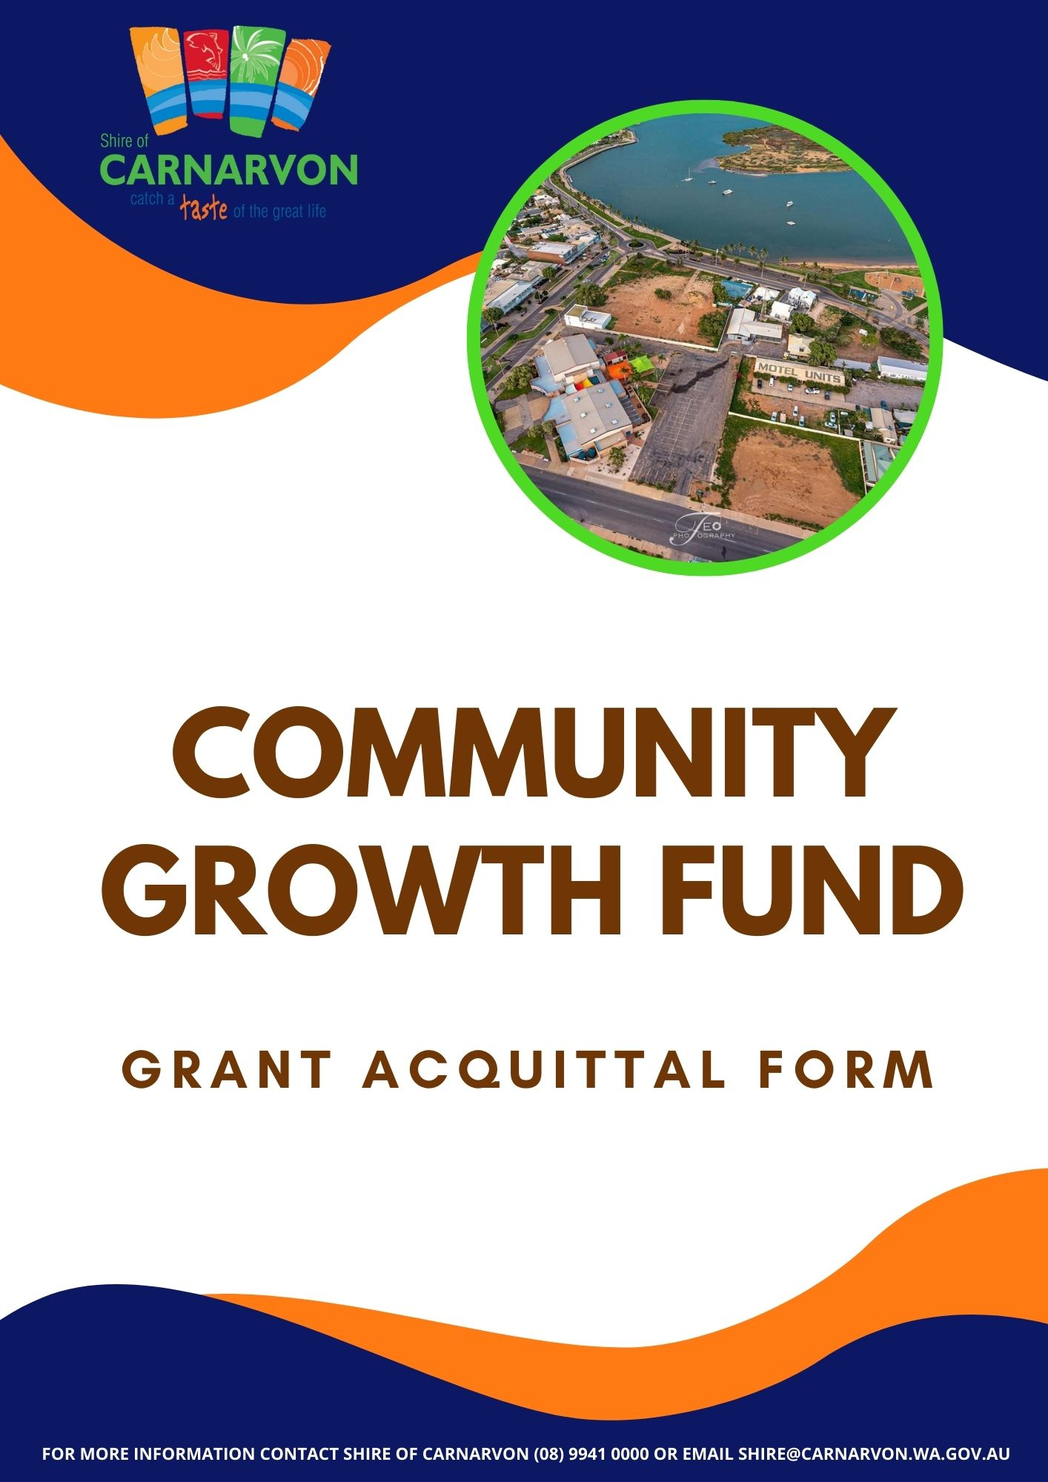

Grant Acquittal Form

To be submitted within twelve (12) weeks of completion of event/project/activity.
(Failure to submit may affect future funding opportunities)

Q1. Organisation/Club: ________________________________________________________________

Q2. Event/Project/Activity Name: ________________________________________________________

Q3. Event/Project/Activity Date: _ _ / _ _ / _ _ _ _

Q4. Festival or Event Summary (200 words or less):

____________________________________________________________________

___________________________________________________________________________________

___________________________________________________________________________________

___________________________________________________________________________________

___________________________________________________________________________________

___________________________________________________________________________________

___________________________________________________________________________________

___________________________________________________________________________________

___________________________________________________________________________________

___________________________________________________________________________________

___________________________________________________________________________________

___________________________________________________________________________________

Q5. Were there any changes to your initial application? ☐ No ☐ Yes – please describe these changes.

____________________________________________________________________

___________________________________________________________________________________

___________________________________________________________________________________

___________________________________________________________________________________

___________________________________________________________________________________

Q6. How many people attended? ___________________

Q7. Which demographics that you indicate on your application attended?

☐ Men ☐ Women
☐ Family ☐ Tourists
☐ Children aged 0-11 yrs ☐ Young people aged 12-25 yrs
☐ Aboriginal or Torres Strait Islander peoples ☐ People with disability/ special need
☐ Other (please specify) _______________________________________________________

Q8. How did the project provide a direct or indirect benefit, including social and economic, to the community? And how did you measure and achieve these? 200 words or less.

____________________________________________________________________

___________________________________________________________________________________

___________________________________________________________________________________

___________________________________________________________________________________

___________________________________________________________________________________

___________________________________________________________________________________

___________________________________________________________________________________

___________________________________________________________________________________

___________________________________________________________________________________

___________________________________________________________________________________

___________________________________________________________________________________

___________________________________________________________________________________

Q9. Reflecting on the project, how did the project meet a need in the community? 200 words or less.

____________________________________________________________________

___________________________________________________________________________________

___________________________________________________________________________________

___________________________________________________________________________________

___________________________________________________________________________________

___________________________________________________________________________________

___________________________________________________________________________________

___________________________________________________________________________________

___________________________________________________________________________________

___________________________________________________________________________________

___________________________________________________________________________________

___________________________________________________________________________________

Q10. The Shire of Carnarvon was promoted in the following manner/s:

☐ Council banners ☐ Logo on the website
☐ MC announcements ☐ Radio/ Television
☐ Keynote speeches ☐ Logo on advertising materials
☐ Social media ☐ Other (please specify) ____________________________

Acquittal

- Please round all amounts to whole dollars.
- Enter all other grants for which you have applied and mark an asterisk against those grants which have already been approved.
- The amounts requested in the third column (SoC*) show how much of the SoC* funding you will allocate to each expenditure item.
- Note: If you are registered for GST, your expenditure and income should be exclusive of GST. If the organisation is not registered for GST, your expenditure should include the gross value (including GST).
- #Please indicate in the left-hand column if the amounts are in-kind (I) or monetary ($).
- Unspent funds are to be returned at time of submitting the acquittal.
*Example of acquittal tables below, please attach yours with application.

Expenses |  | Cost | *SoC Grant | +/- from Budgeted Amount
#
Total Expenses |  | $ | $ | $

Income (includes in-kind contributions)
#
Total Expenses |  | $ | $ | $

Checklist

Have you included:

☐ Budget information
☐ Copies of receipts for accounts/invoices paid
☐ Proof of Shire’s acknowledgement, i.e., Programs, advertising, etc.
☐ Photographs of event/project/activity
☐ Additional information (if required)

I certify that:

- The information provided above with respect to the expenditure of donation/contribution monies is true and accurate, and the funds have been applied in accordance with the purposes of the donation/contribution.
- Any unexpended funds have been returned to Council.
- In providing the supplied content, including photographs, graphics, logos and/or any other content, you warrant that consent has been obtained and/or is given for the purpose of supplying to the Shire for the Community Growth Fund. Further, in providing the supplied content, you explicitly permit the collection and use of the supplied content by the Shire, which may be used, copied, stored, adapted, printed, published, advertised, promoted and/or reproduced without further notice, acknowledgment, remuneration or compensation.

Signed by: Date:

☐ Chairperson ☐ Treasurer ☐ Secretary of Applicant/Organisation

Please return to:

Postal address: Hand Delivery:
Chief Executive Officer Chief Executive Officer
Shire of Carnarvon Shire of Carnarvon
PO Box 459 3 Francis Street
CARNARVON WA 6701 CARNARVON WA 6701
Email: shire@carnarvon.wa.gov.au

